Data from Bradford Teaching Hospitals NHS Foundation Trust from week beginning 24 September 2017 to 07 November 2021 (216 weeks). The data cover XX orders from XX patients. An order can be xx.

Within the data period there are 3,086 unique personnel ID’s relating to the doctor carrying out the order. For each week in the data we observed the number of patients seen and orders created for each doctor. Figure 1 presents data on the total number of patients seen and orders created for each week between September 2017 and November 2021.

Figure 1: total patients and orders per week September 2017 to November 2021

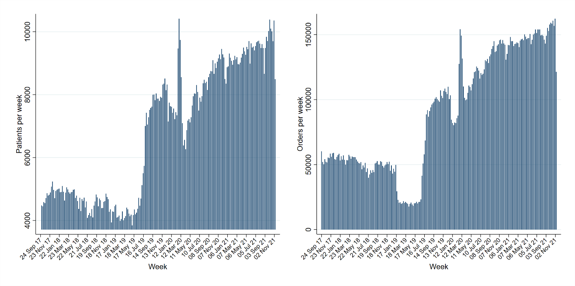

Figure 2: patients and orders per doctor

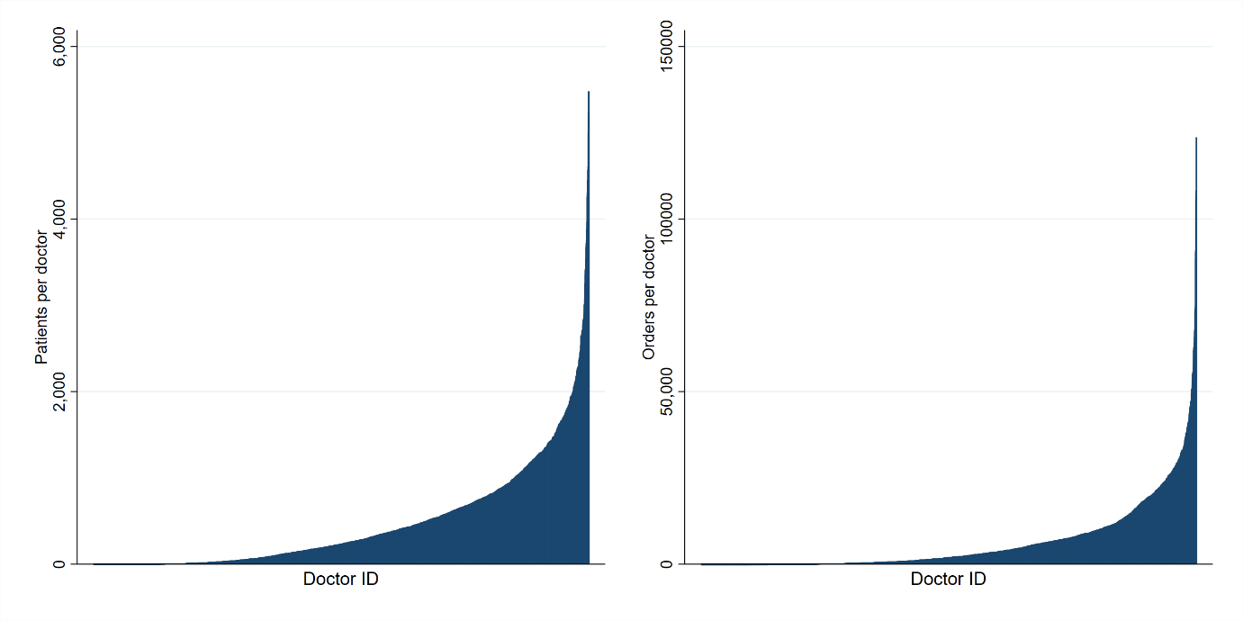

Figure 2: patients and orders per doctor [excluding top 1%]

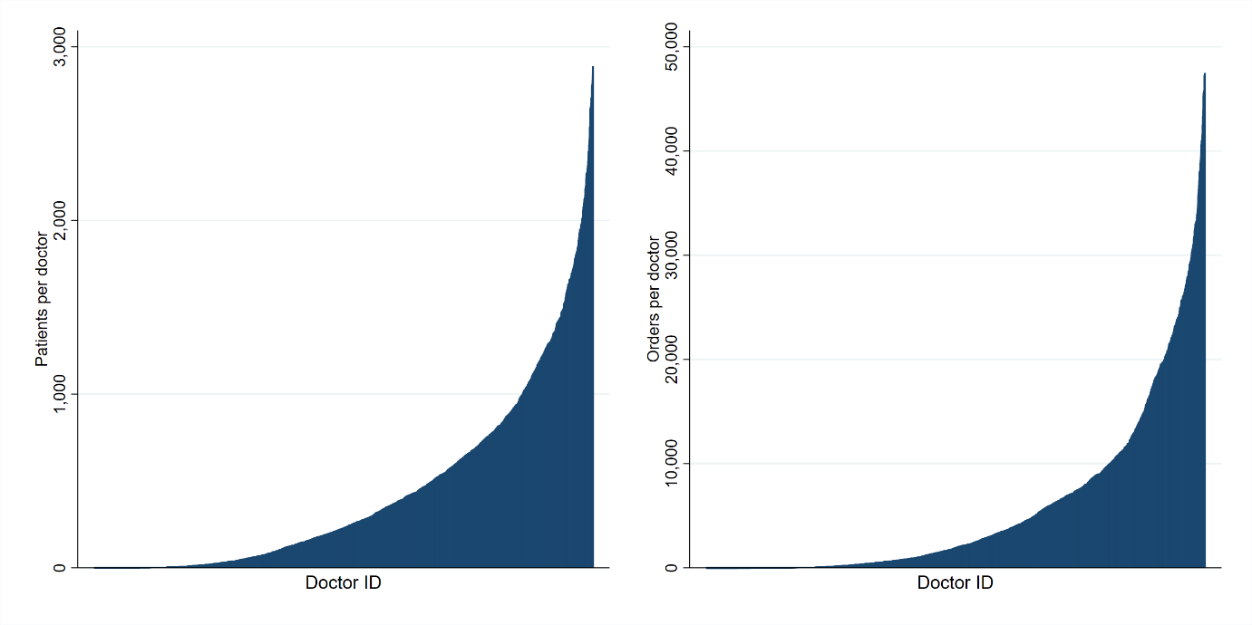

Due to the drop in orders observed in 2019 and the impact of COVID 19, our case study analysis focuses on 52 weeks from 24th September 2017 to 16th September 2018. Doctor who treated no patients over this period are removed leaving

